2015 May 6

Youngseok Kim, Seokju hong

team 2

Design model

SafeHome Project

Table of Contents

1. Introduction 4

1.1. Document introduction 4

1.2. Assumptions 4

1.3. Additional note 4

2. Sequence diagram 5

2.1. SafeHome bootup/shutdown service 5

2.1.1. bootup (UC1-1) 5

2.1.2. Test device (UC1-2, UC1-3) 6

2.2 SafeHome configuration service 8

2.2.1. Password registration (UC2-1, UC2-2) 8

2.2.2. Configure security zone (UC2-3) 9

2.2.3. Session timeout (UC2-4) 10

2.2.4. Login 11

2.2.5 Logout 12

2.3. SafeHome real-time security service 13

2.3.1. Arm all devices (UC3-1) 13

2.3.2. Disarm all devices (UC3-3) 14

2.3.3. Arm single device (UC3-2) 15

2.3.4. Disarm single device (UC3-4) 16

2.3.5. Alarm Home (UC3-5) 17

2.3.6. Alarm user (UC3-6) 18

2.3.7. Alarm-emergency agent (UC3-7) 19

2.3.8. Set travel mode (UC3-8) 20

2.3.9. Lighting Heating Control 21

2.3.10. Detect motion (UC3-9) 22

2.3.11. Detect window action 23

2.3.12. Detect high gas concentration 24

2.3.13. Fire detection 25

2.3.14. Detect dog barking 26

2.3.15. Camera view 27

2.3.16. Record camera 28

2.3.17. Camera zoom 29

2.3.18. Camera pan 30

2.3.19. Replay recorded movie 31

2.4. User-requested information retrieval service 32

2.4.1. Find ID/PW 32

2.4.2. Report system usage pattern 33

2.4.3. Report page access history 34

3. State diagram 35

3.1. Main computer 35

3.2. Event handlin 36

3.3. management interfaces 37

3.4. SafeHome console 38

4. Class diagram 39

4.1. SafeHome application 39

4.2. SafeHome console 40

A. Authorship 41

B. Terminology 42

# Introduction

## Document introduction

This document is a SafeHome project Phase 3 which contains design model for the SafeHome product. This document contains sequence diagrams, class diagrams, and state diagrams. This document is written by Young Seok Kim and Seokju Hong. Since the scope of the project has been changed, revision of the software requirement specification and analysis model was inevitable, so the authors had to revise the software requirement specification document and analysis model document in order to write this design model document. This document is written for the developers as well as professor, TAs and other students. This document is based on the revised software requirement specification document and “Sample SRS overview” document from the professor. All of the diagrams in this document is drawn with StarUML software with limited evaluation license.

## Assumptions

Only one user can configure the SafeHome system simultaneously.

(Concurrent access to the SafeHome system is not allowed.)

There is only one control panel in the house.

Internet connection between a home owner and the SafeHome system is always available.

All devices including camera(s), sensor(s), and the SafeHome main system communicate using IEEE 802.11x protocol.

## Additional note

Note that in 2.2, the login and logout feature is added. The previous document implicitly explained about the login and logout. In this design model document, these features are explicitly written because they are used frequently in other features. Words like “UC1-1” inside the parenthesis means it’s a link toward the use case in Analysis model or SRS.

# Sequence diagram

## SafeHome bootup/shutdown service

### 2.1.1. bootup (UC1-1)

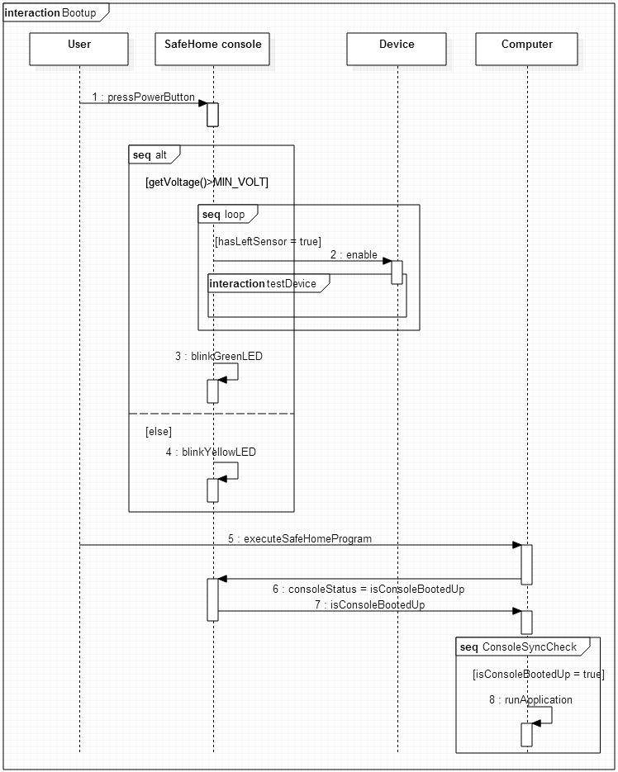

* + 1. Test device (UC1-2, UC1-3)  
         
       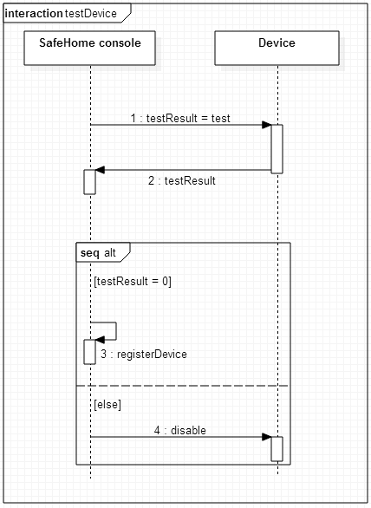
    2. 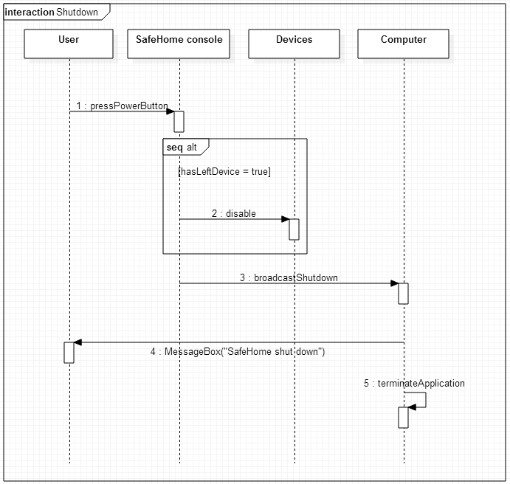shutdown (UC1-4)

## 2.2 SafeHome configuration service

### 2.2.1. Password registration (UC2-1, UC2-2)

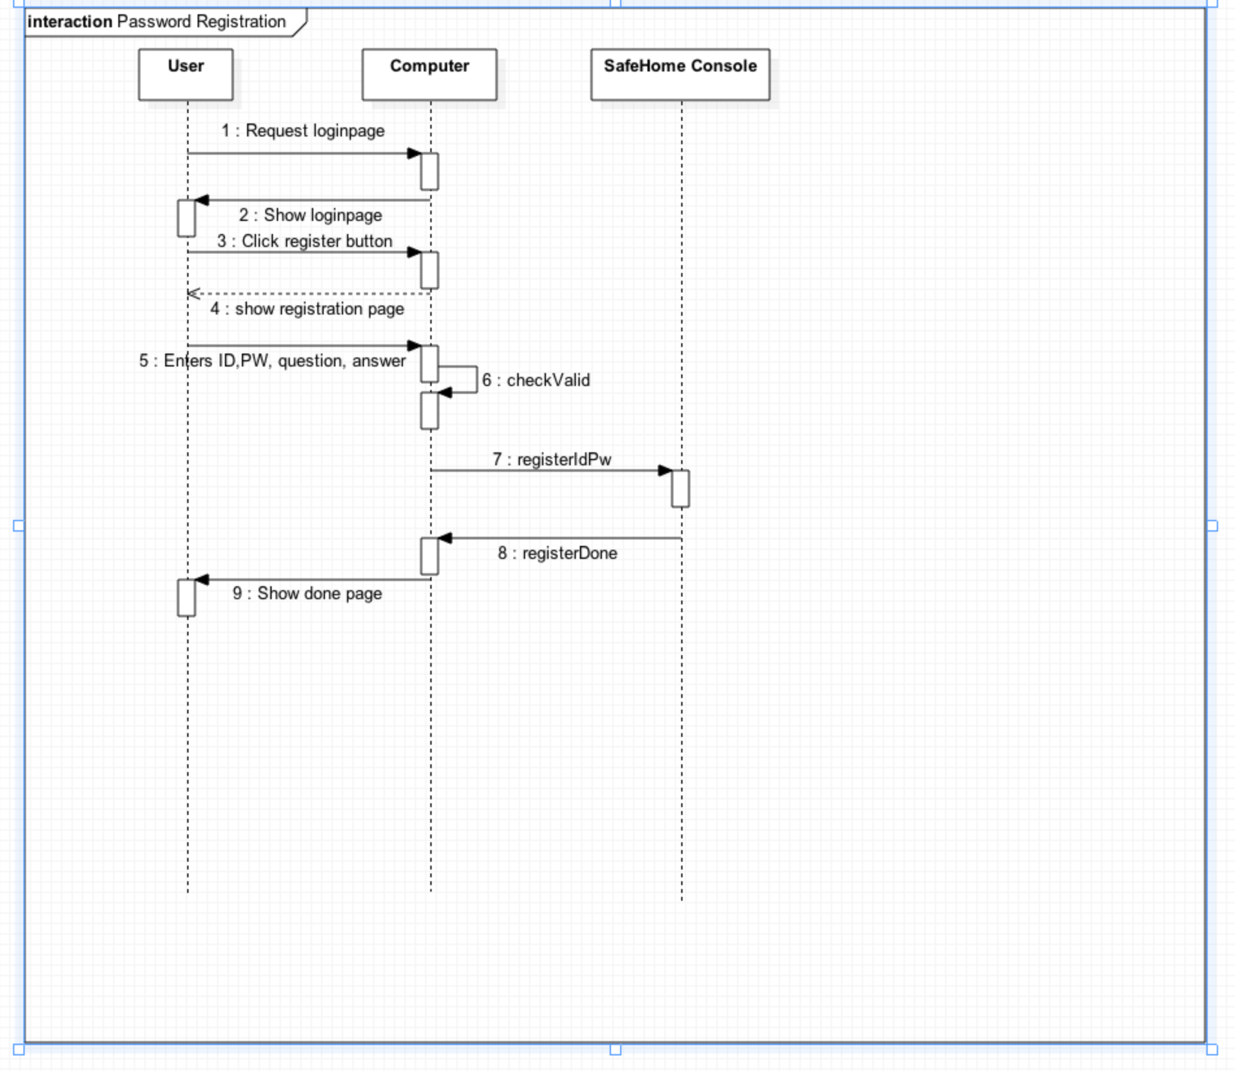

### 2.2.2. Configure security zone (UC2-3)

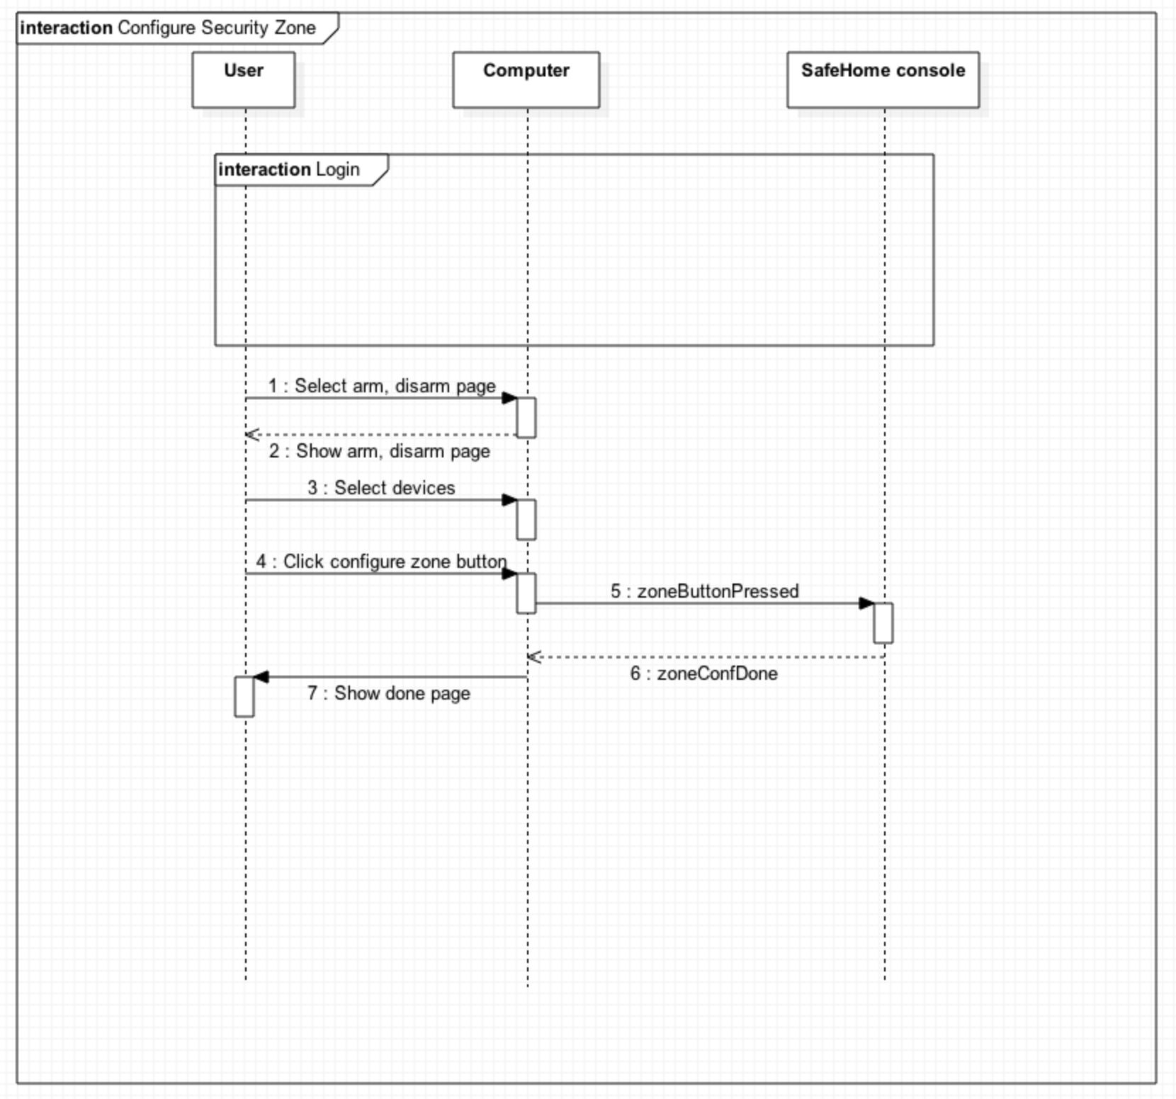

### 2.2.4. Login

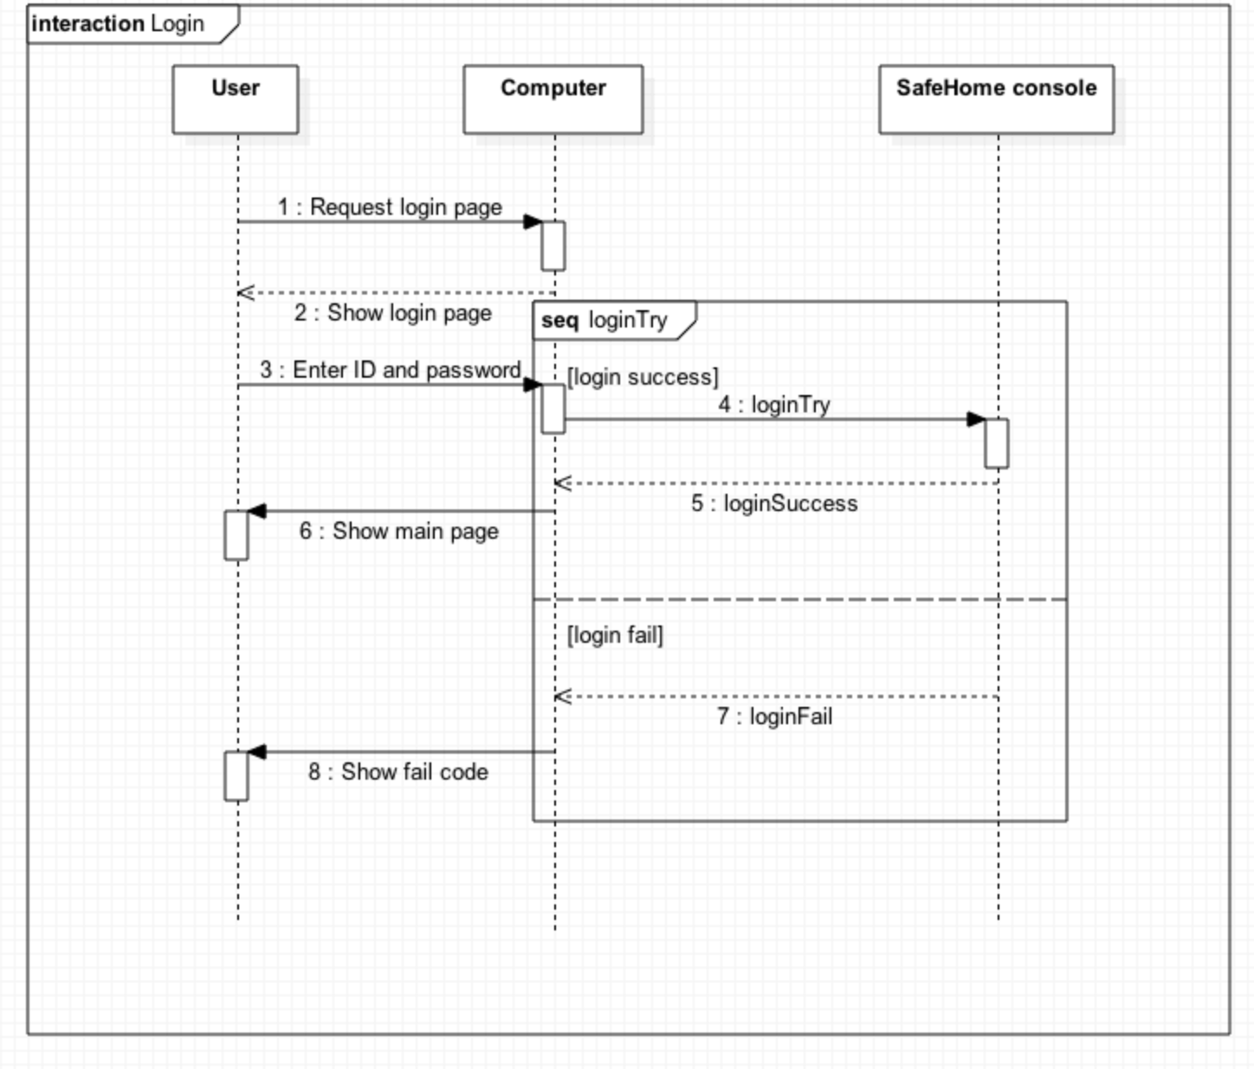

### 2.2.5 Logout

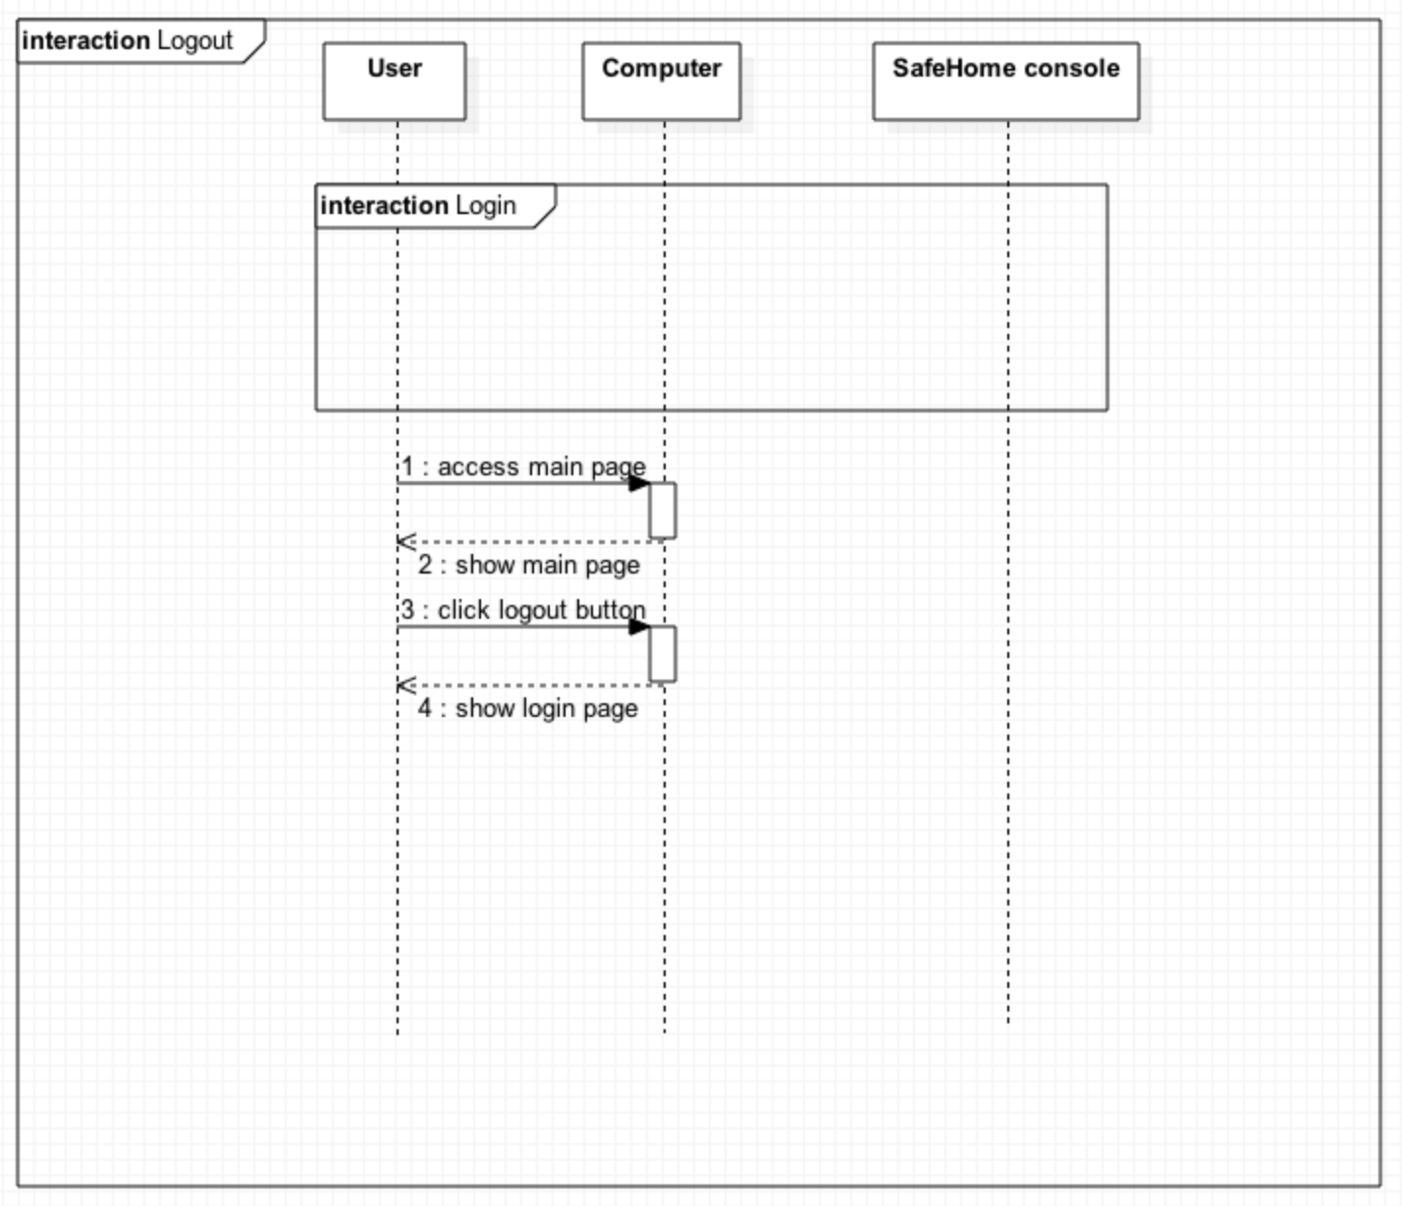

## 2.3. SafeHome real-time security service

### 2.3.1. Arm all devices (UC3-1)

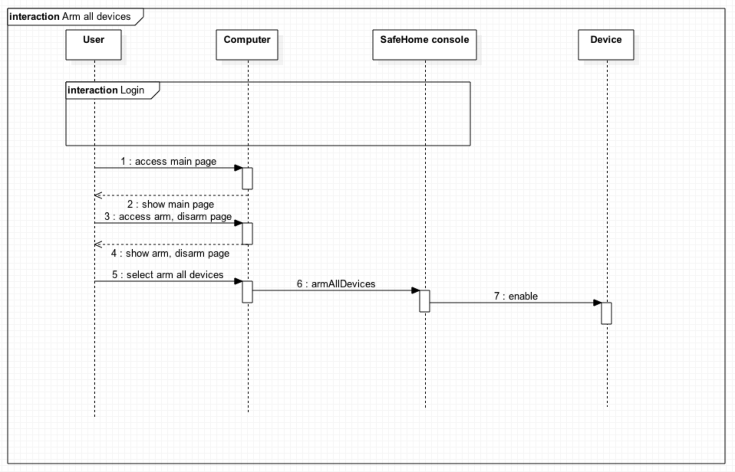

### 2.3.2. Disarm all devices (UC3-3)

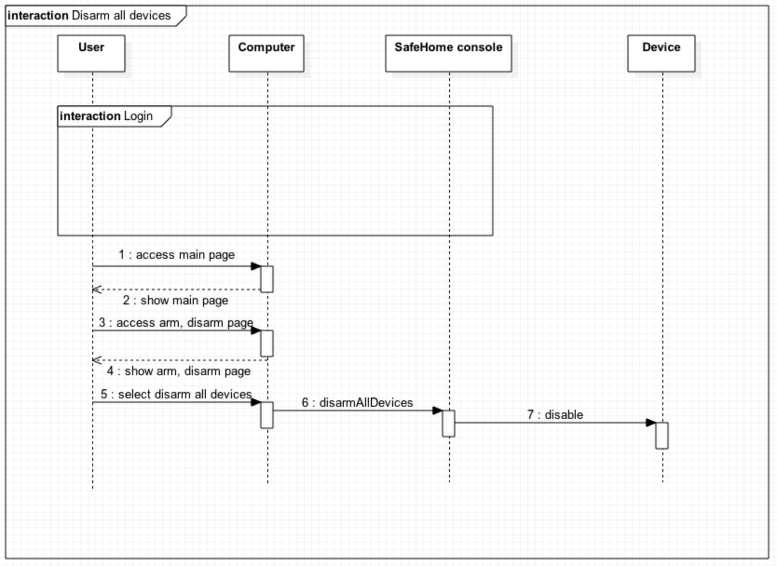

### 2.3.3. Arm single device (UC3-2)

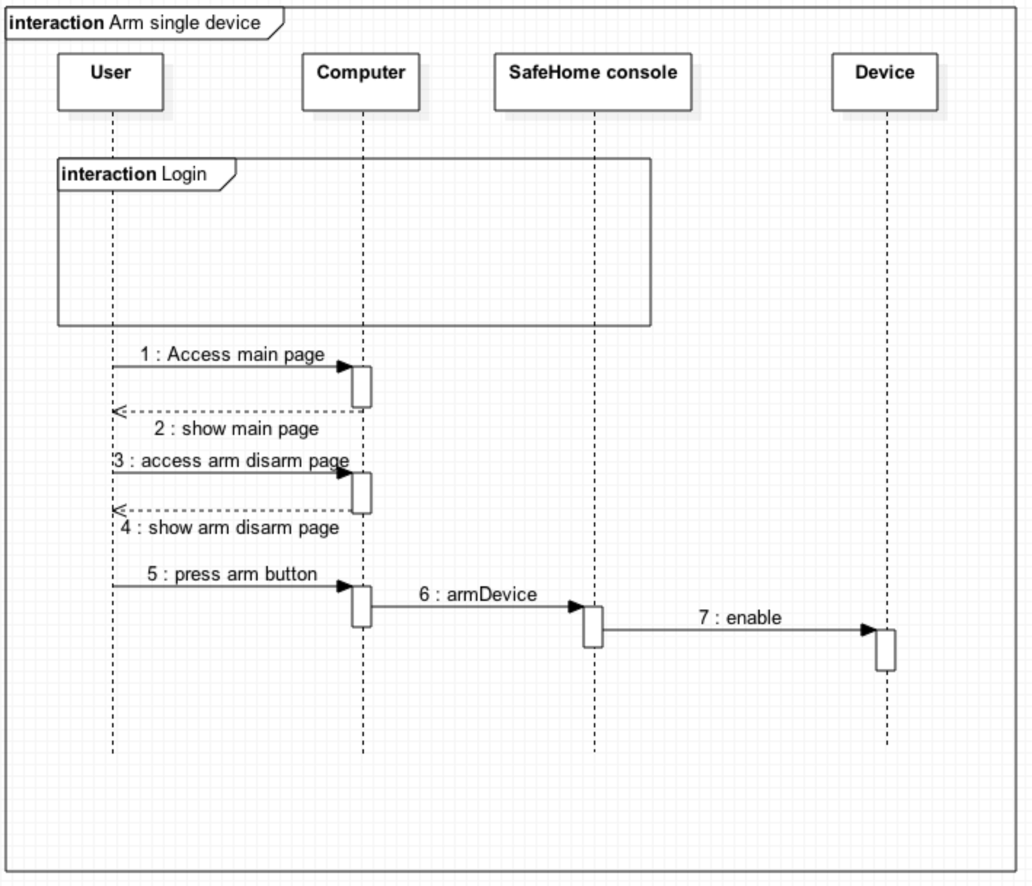

### 2.3.4. Disarm single device (UC3-4)

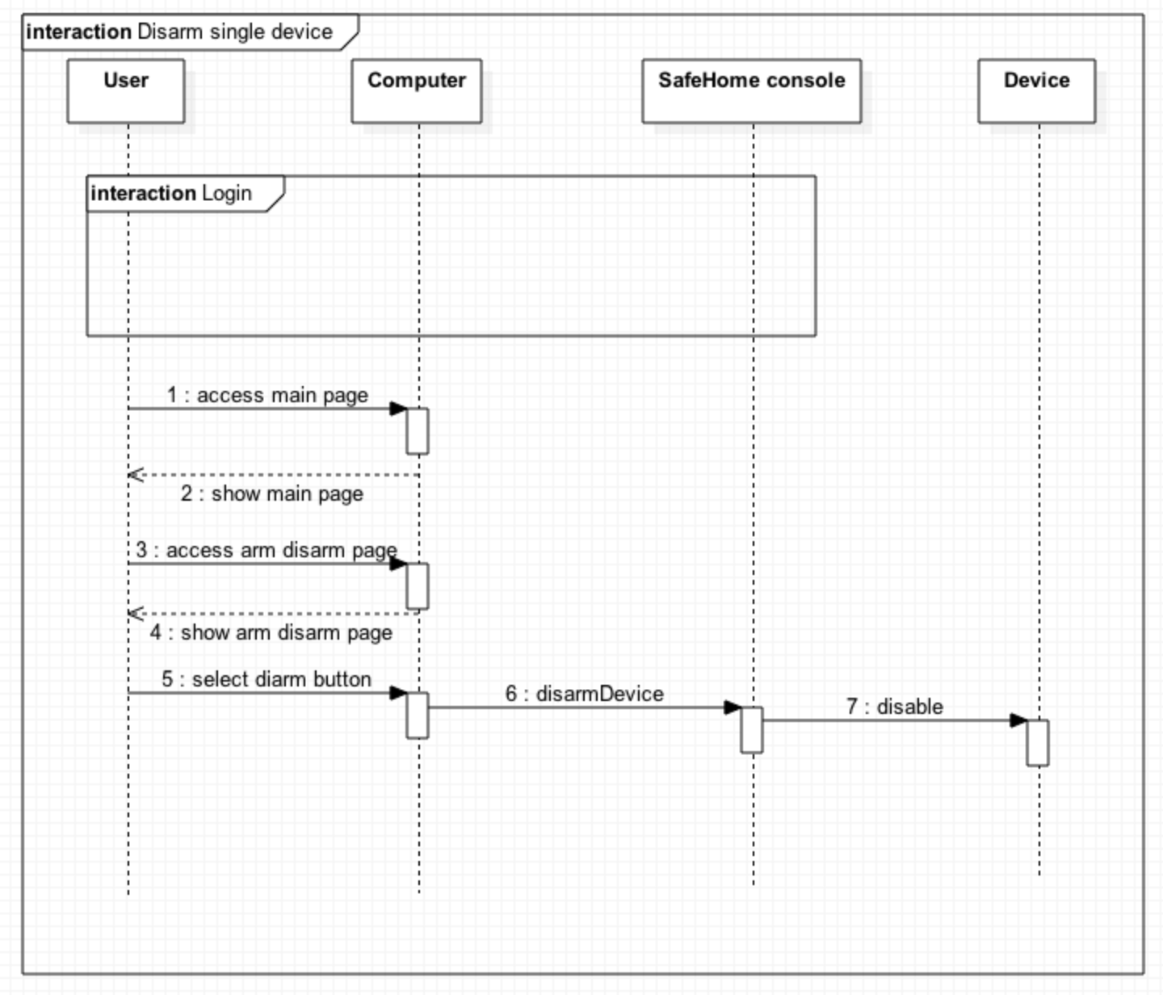

### 2.3.5. Alarm Home (UC3-5)

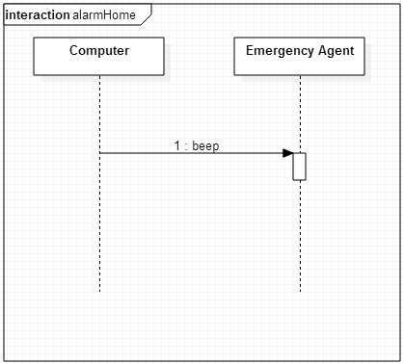

### 2.3.6. Alarm user (UC3-6)

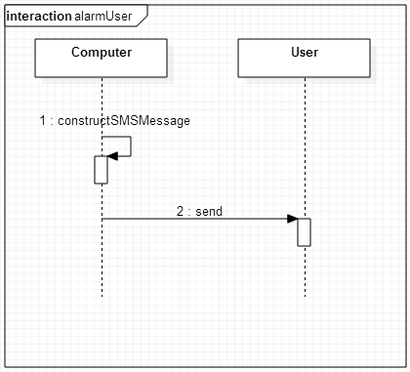

### 2.3.7. Alarm-emergency agent (UC3-7)

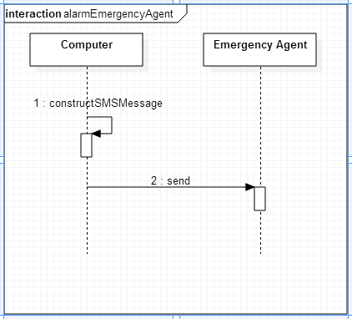

### 2.3.10. Detect motion (UC3-9)

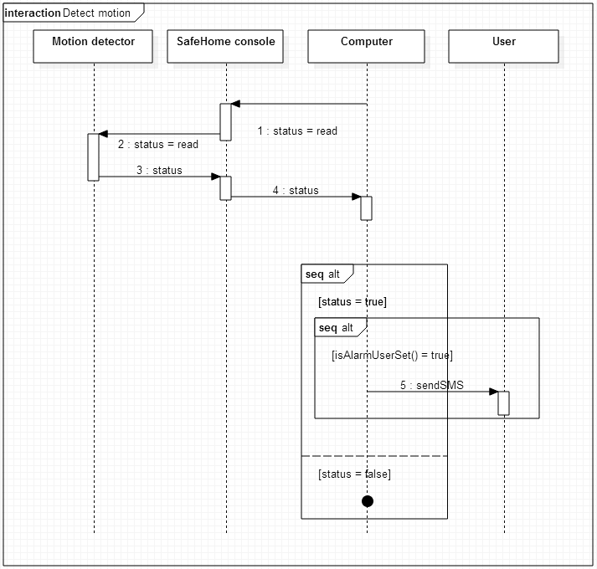

2.3.11. Detect window action (UC3-10)  
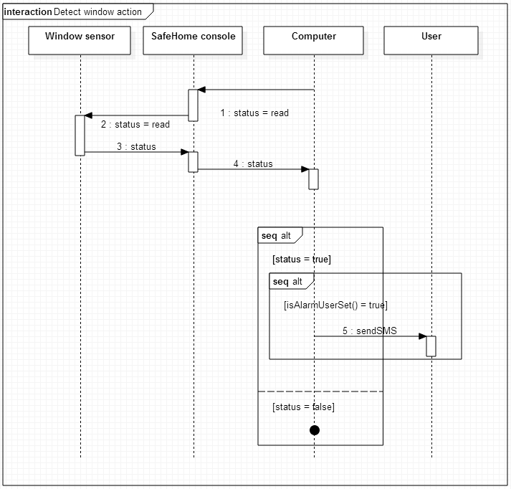

### 2.3.15. Camera view (UC3-14)

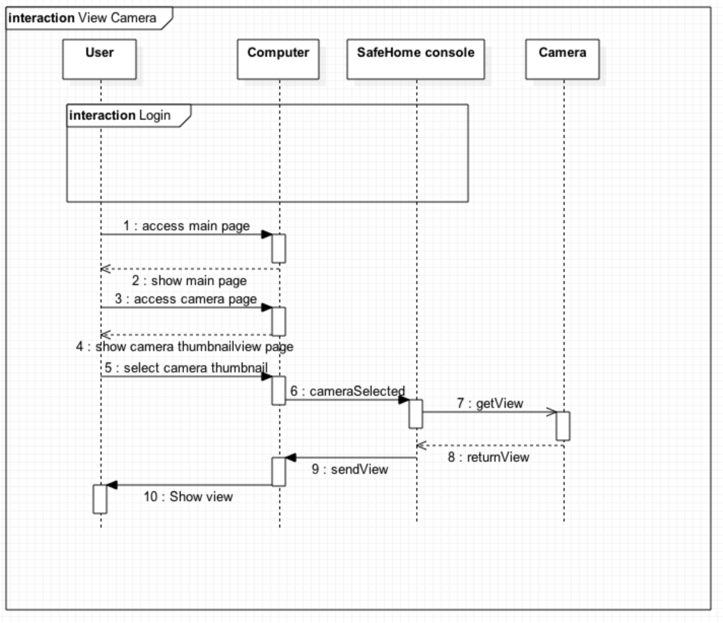

### 2.3.17. Camera zoom (UC3-17)

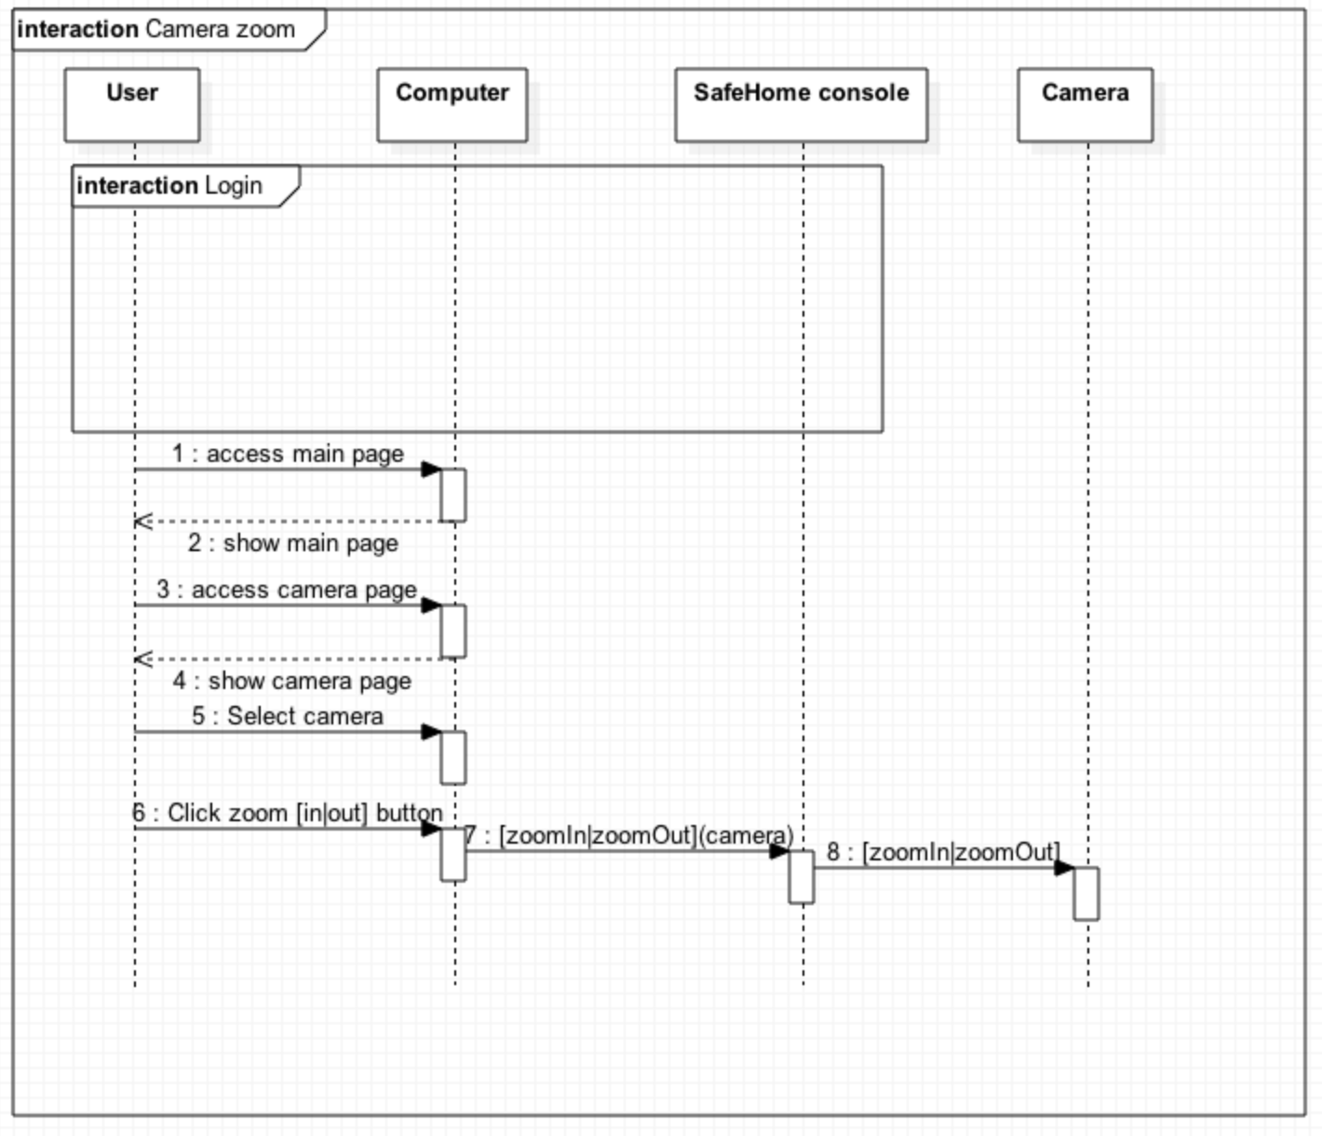

### 2.3.18. Camera pan (UC3-18)

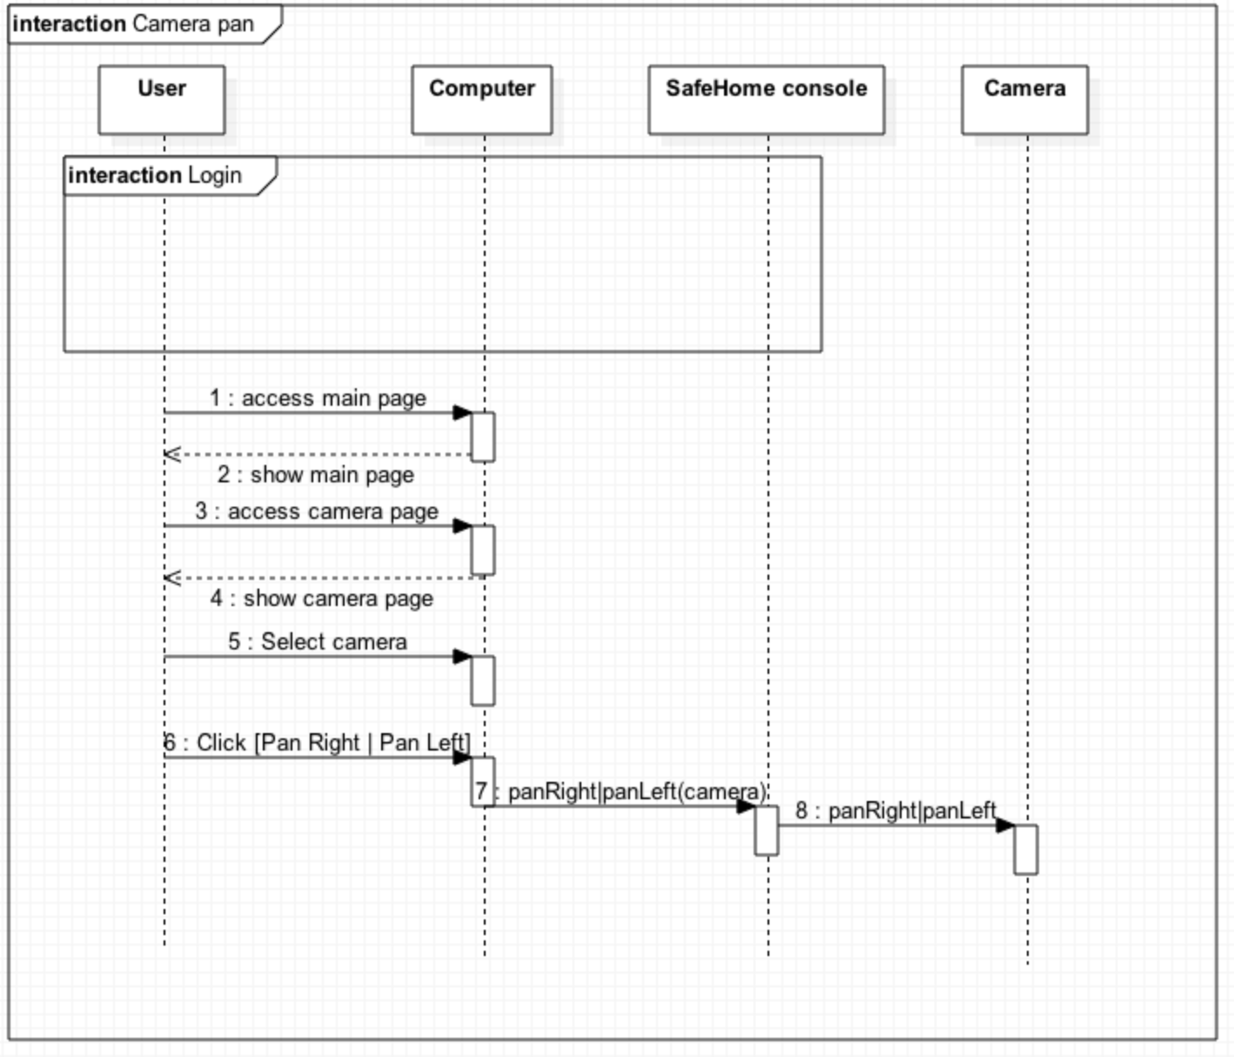

# State diagram

## Main computer

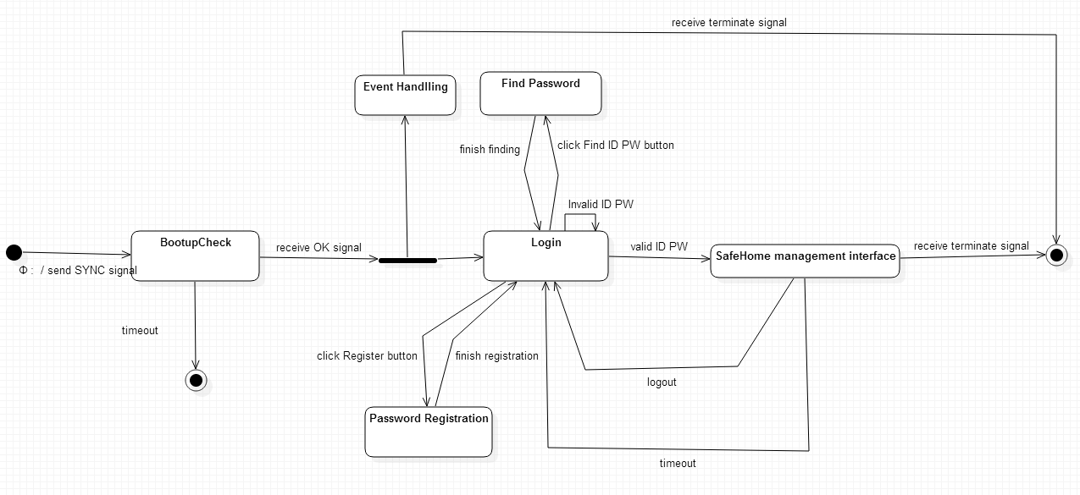

* 1. Event handling

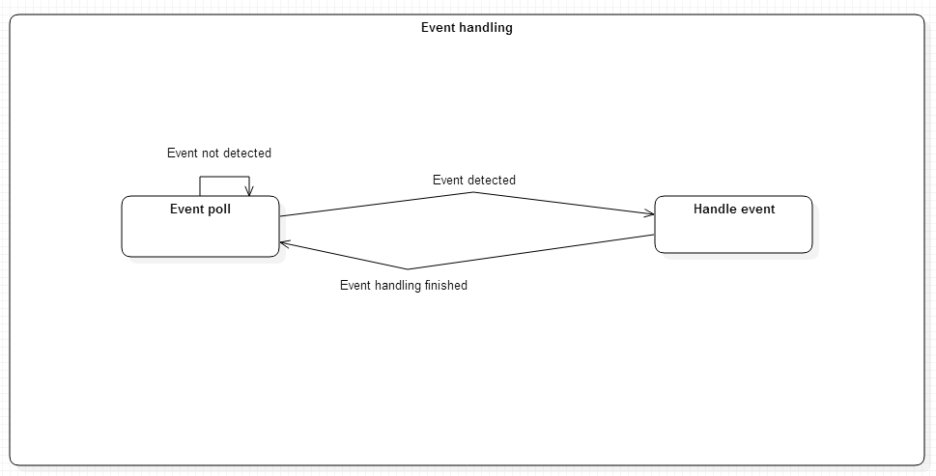

## management interfaces

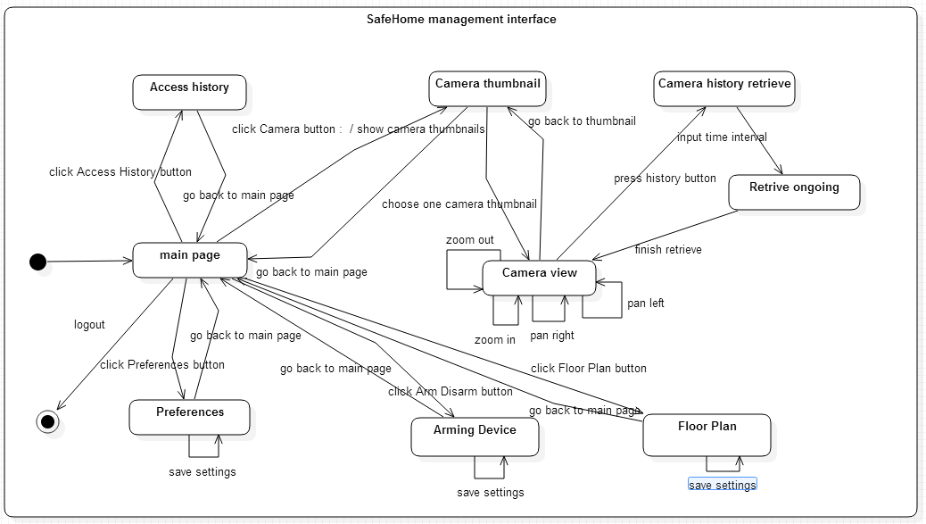

## SafeHome console

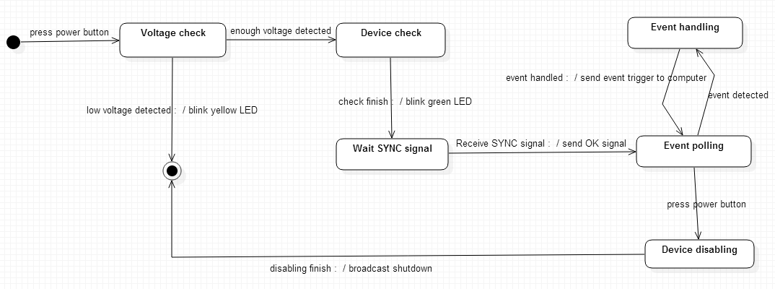

# Class diagram

## C:\Users\Tony Kim\Desktop\SE\SafeHomeApplication.PNGSafeHome application

## SafeHome console

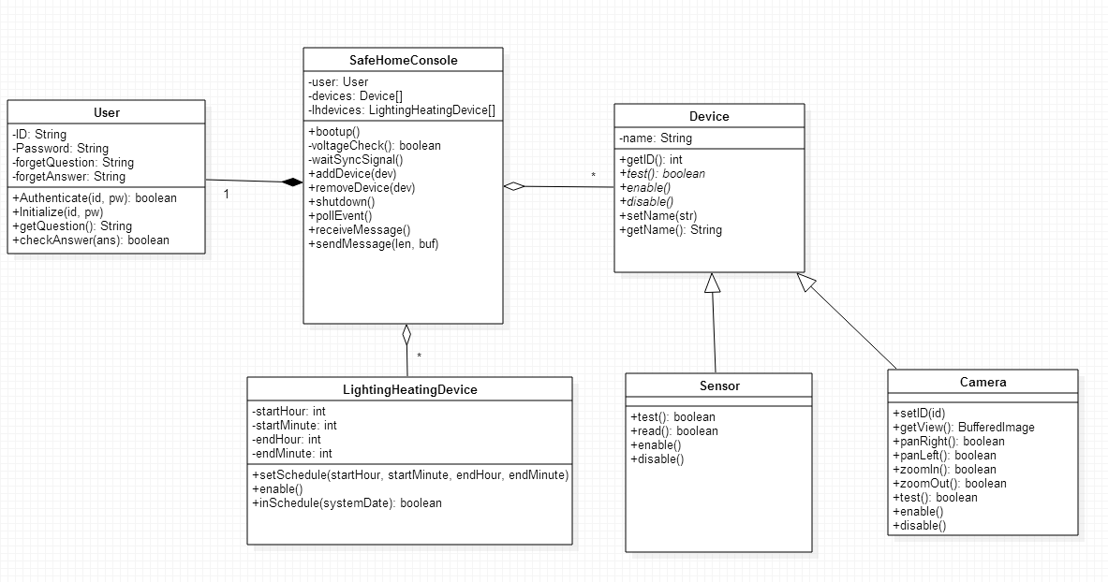

# Authorship

**1 – Introduction**

Introduction is written by Young Seok Kim

**2 – Sequence diagram**

2.1. is written by Seokju Hong.

2.2. is written by Young Seok Kim

2.3.1 ~ 2.3.4 is written by Young Seok Kim

2.3.5 ~ 2.3.13 is written by Seokju Hong

2.3.13 ~ 2.3.18 is written by Young Seok Kim

2.4 is written by Young Seok Kim

**3 – State diagram**

Four diagrams are designed and written together (Seokju Hong and Young Seok Kim)

**4 – Class diagram**

Class diagram is designed and written together (Seokju Hong and Young Seok Kim)

# Terminology

**SafeHome console**

“SafeHome console” means the hardware box which communicates with sensors, cameras, and server via IEEE 802.11(a.k.a. Wi-Fi).

**SafeHome server**

“SafeHome server” means the server computer which saves camera data, sensor data, and other security data. In addition, the server also provides web service in which user can access through the internet, and configure SafeHome system.

**User/Home owner/customer**

User, or Home owner, or customer means people who use this product. All the family members are included.

**Sensor**

A sensor means a device which measures environmental data of the house. In addition, a sensor can communicate with the SafeHome console, and alert the SafeHome console if the measured value of the sensor is abnormal.

**Camera**

A camera is a device which is used in surveillance system. The camera can provide real-time view and record. The SafeHome console communicates with the camera to zoom, pan, and receive data. The resolution of the recorded data is saved in 480p with H.264 MPEG-4 format.

**Device**

Devices mean either sensors or cameras.

**Lighting Heating Device**

Lighting heating devices mean any apparatus related with temperature control, or related with light control.

**SafeHome system**

SafeHome system includes the SafeHome server and the SafeHome console.

**Control panel**

A control panel means a panel with 12 buttons([0-9|#|*]) and a small touch display. The user can configure the SafeHome system with this control panel. The control panel is installed in the house.

**Web interface (Web control panel)**

Web interface, or web control panel means web page provided by the SafeHome server in order to configure the SafeHome system. (Note that this feature is removed by professor)